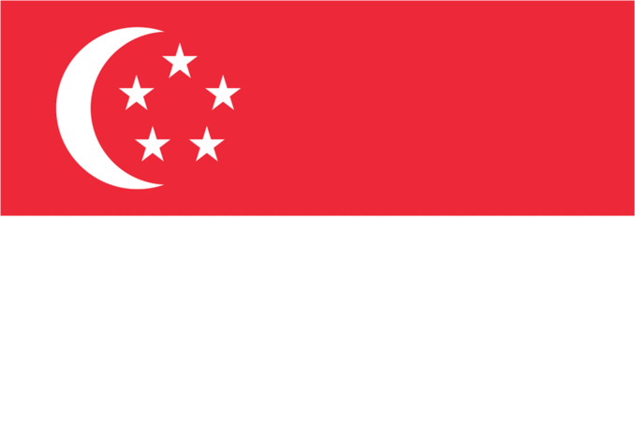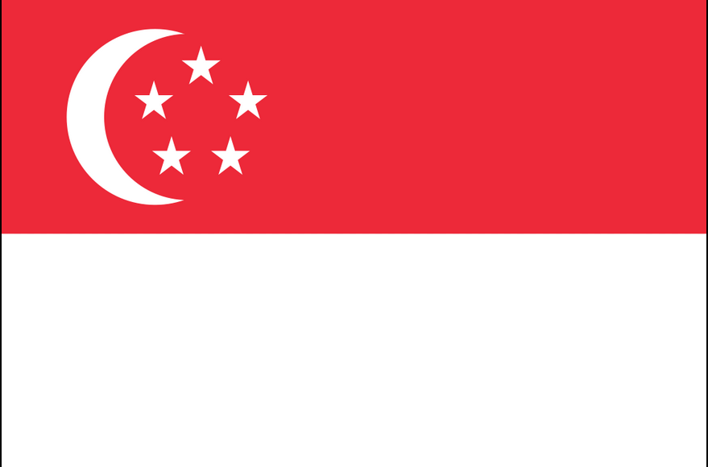

FLAG OF SINGAPORE

CUISINE

Dining, along with shopping, is said to be the country's national pastime. The focus on food has led countries like Australia to attract Singaporean tourists with food-based itineraries. The diversity of food is touted as a reason to visit the country, and the variety of food representing different ethnicities is seen by the government as a symbol of its multiculturalism.[ The "national fruit" of Singapore is the durian.

In popular culture, food items belong to a particular ethnicity, with Chinese, Malay, and Indian food clearly defined. However, the diversity of cuisine has been increased further by the "hybridisation" of different styles (e.g., the Peranakan cuisine, a mix of Chinese and Malay cuisine).

LANGUAGE

Many Singaporeans, are bilingual. Most speak Singaporean English and another language, most commonly Mandarin, Malay, Tamil or Singapore Colloquial English (Singlish). Singapore Standard English is virtually the same as British, Malaysian, and Indian Standard English in most aspects of grammar and spelling, though there are some differences vocabulary and minor spelling differences, for example the word 'swap' is commonly spelt 'swop', as is standard in the Straits Times

All Singaporeans study English as their first language in school, under the compulsory local education system, and their mother-tongue language as their second language. Thus, most Singaporeans are effectively bilingual, especially the youths in today's society. There are four main languages in usage in Singapore. The 'national' language of Singapore is Bahasa Melayu. This is in recognition of the Malay people as the indigenous community in Singapore. 85% of Singaporeans do not speak Malay. Malay is used in the national anthem, national motto and military parade drill commands. Tamil is an official language as a majority of South Asians in Singapore are ethnic Tamils from India and Sri Lanka. While most Chinese Singaporeans are descendants of southern Chinese migrants who spoke a variety of regional languages, it is the northern Chinese language of Mandarin that is official in Singapore, though dialects such as Hokkien and Cantonese are still prevalent in the older generation of Chinese.



**Singapore**

**Singapore City**

ENTERTAINMENT

As a country proud of its multicultural population, Singapore offers a mix of ethnic and international entertainment throughout the year. International pop stars such as Elton John and the Rolling Stones regularly perform there. For the connoisseur of classical art forms, Singapore offers opera, the Singapore Symphony, the Chinese Orchestra, Indian classical music and a variety of dance companies that perform classical and modern dance from around the globe. In addition to the classical arts, Singapore is home to comedy clubs, movie theaters and local theater groups. The Singapore Art Museum and Asian Civilizations Museum are just two of the many venues for art enthusiasts.

CLIMATE

Singapore has a tropical rainforest climate with no distinctive seasons, uniform temperature and pressure, high humidity, and abundant rainfall. Temperatures usually range from 22 to 35 °C (72 to 95 °F). Relative humidity averages around 79% in the morning and 73% in the afternoon. April and May are the hottest months, with the wetter monsoon season from November to January. From July to October, there is often haze caused by bush fires in neighboring Indonesia, usually from the island of Sumatra. Although Singapore does not observe daylight saving time (DST), it follows the GMT+8 time zone, one hour ahead of the typical zone for its geographical location.

**TRANSPORT**

Singaporean residents also travel by foot, bicycles, bus, taxis and train (MRT or LRT). Two companies run the public bus and train transport system—SBS Transit and SMRT Corporation. There are six taxi companies, who together put out over 28,000 taxis on the road. Taxis are a popular form of public transport as the fares are relatively cheap compared to many other developed countries.

**ARTS AND CULTURE**

Since the 1990s, the government has been promoting Singapore as a centre for arts and culture, in particular the performing arts, and to transform the country into a cosmopolitan "gateway between the East and West". One highlight was the construction of Esplanade – Theatres on the Bay, a performing arts centre opened in October 2002. The national orchestra, Singapore Symphony Orchestra, plays at the Esplanade. The annual Singapore Arts Festival is organised by the National Arts Council. The stand-up comedy scene has been growing, with a weekly open mic.



LANDMARKS

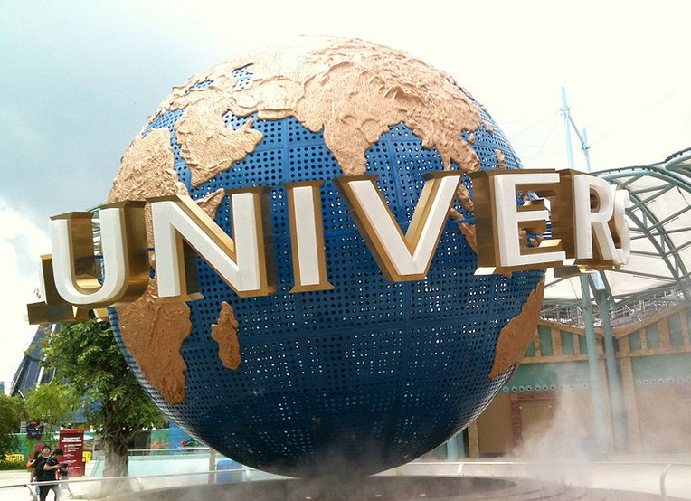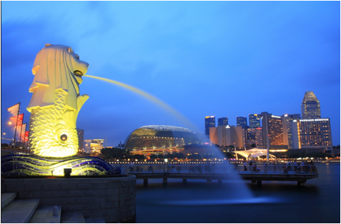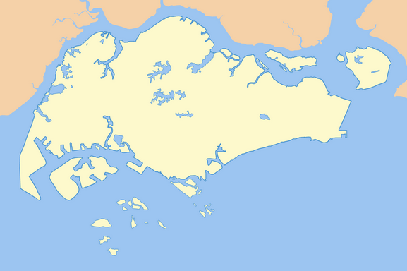

RECREATIONAL ACTIVITIES Favourite Singaporean sports include outdoor sports such as football, basketball, cricket, swimming, sailing and various indoor sports such as table tennis and badminton. Most Singaporeans live in public residential areas with amenities such as public swimming pools, outdoor basketball courts and indoor sport complexes nearby. As might be expected on an island, water sports such as sailing, kayaking and water skiing are popular. Scuba diving is another recreation, particularly around the southern island of Pulau Hantu which is known for its rich coral reefs

Universal Studios Singapore

Merlion Park

GEOGRAPHY

Singapore consists of 63 islands, including the main island, widely known as Singapore Island or Pulau Ujong in Malay. There are two man-made connections to Johor, Malaysia: the Johor–Singapore Causeway in the north and the Tuas Second Link in the west. Jurong Island, Pulau Tekong, Pulau Ubin and Sentosa are the largest of Singapore's smaller islands. The highest natural point is Bukit Timah Hill at 163.63 m (537 ft).

Ongoing land reclamation projects have increased Singapore's land area from 581.5 km2 (224.5 sq mi) in the 1960s to 719.1 km2 (277.6 sq mi) presently. The country is projected to grow by another 100 km2 (40 sq mi) by 2030. Some projects involve merging smaller islands through land reclamation to form larger, more functional islands, as has been done with Jurong Island

.

Singapore (i/ˈsɪŋəpɔr/ or /ˈsɪŋɡəpɔr/), officially the Republic of Singapore, and often referred to as the Lion City, the Garden City, and the Red Dot, is a leading global city-state and island country in Southeast Asia. It lies at the southernmost tip of continental Asia, one degree (137 km; 85 mi) north of the equator, and is separated from Peninsular Malaysia by the Straits of Johor to the north and from Indonesia's Riau Islands by the Singapore Strait to the south. Singapore's territory consists of the diamond-shaped main island (commonly referred to as Singapore Island and Pulau Ujong in Malay) and more than 60 significantly smaller islets. Since the 1960s, ongoing land reclamation has increased Singapore's land area, which is highly urbanised, by at least 20%.