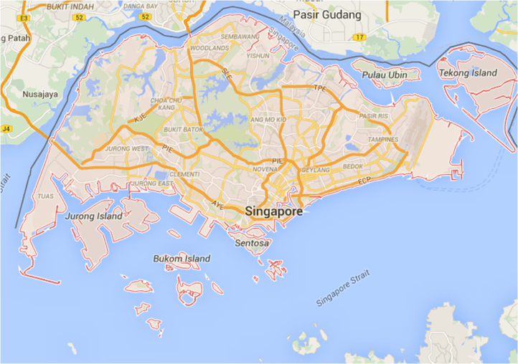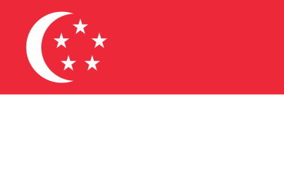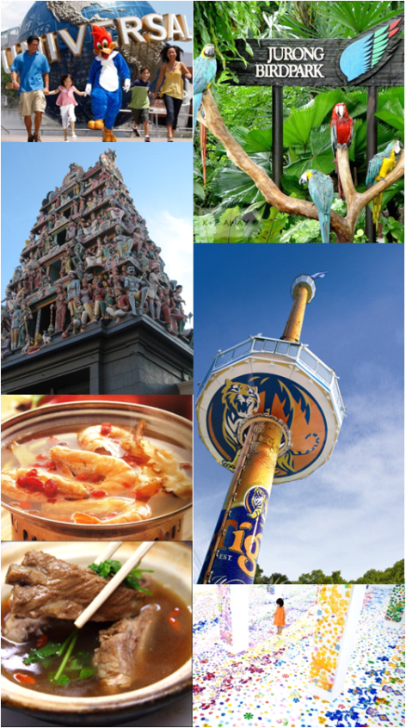https://cdn1.iconfinder.com/data/icons/windows-8-metro-style/128/left_round.pnghttps://cdn1.iconfinder.com/data/icons/windows-8-metro-style/128/left_round.pnghttps://cdn1.iconfinder.com/data/icons/windows-8-metro-style/128/left_round.pnghttps://upload.wikimedia.org/wikipedia/commons/thumb/f/fe/Windows_8_logo_and_wordmark.svg/1280px-Windows_8_logo_and_wordmark.svg.pngZ:\My Documents\Downloads\Other-Power-Log-Off-Metro-icon.pnghttp://files.softicons.com/download/system-icons/windows-8-metro-invert-icons-by-dakirby309/png/256x256/Other/Power%20-%20Restart.pnghttp://files.softicons.com/download/system-icons/windows-8-metro-invert-icons-by-dakirby309/png/256x256/Other/Power%20-%20Shut%20Down.png

Google Maps

official flag

coordinates

1.3000° N, 103.8000° E

national anthem

Majulah Singapura

land area

Singaporean

GDP

Int$452.686 billion

Sing. Dollar

land area

718.3 km2

form of government

Constitutional monarchy

religion

Buddhism

official language

English, Mandarin, Malay, Tamil

5,469,700 (2014)

official name

The Republic of Singapore

**Summary**

**Singapore** (/ˈsɪŋəpɔr/ or /ˈsɪŋɡəpɔr/), officially the Republic of Singapore, and often referred to as the Lion City, the Garden City, and the Red Dot, is a leading global city-state and island country in Southeast Asia. It lies at the southernmost tip of continental Asia, one degree (137 km; 85 mi) north of the equator, and is separated from Peninsular Malaysia by the Straits of Johor to the north and from Indonesia's Riau Islands by the Singapore Strait to the south. Singapore's territory consists of the diamond-shaped main island (commonly referred to as Singapore Island and Pulau Ujong in Malay) and more than 60 significantly smaller islets. Since the 1960s, ongoing land reclamation have increased Singapore's land area, which is highly urbanised, by at least 20%.

**Geography**

Singapore consists of 63 islands, including the main island, widely known as Singapore Island or Pulau Ujong in Malay. There are two man-made connections to Johor, Malaysia: the Johor–Singapore Causeway in the north and the Tuas Second Link in the west. Jurong Island, Pulau Tekong, Pulau Ubin and Sentosa are the largest of Singapore's smaller islands. The highest natural point is Bukit Timah Hill at 163.63 m (537 ft).

Ongoing land reclamation projects have increased Singapore's land area from 581.5 km2 (224.5 sq mi) in the 1960s to 718.3 km2 (277.3 sq mi) presently. The country is projected to grow by another 100 km2 (40 sq mi) by 2030.[91] Some projects involve merging smaller islands through land reclamation to form larger, more functional islands, as has been done with Jurong Island.

about Singapore

Singapore

Singapore

Singapore City

Singapore

Angelo

angelokadusale